Email – Announcement
Please use the image included in the marketing materials zip file for FB Header
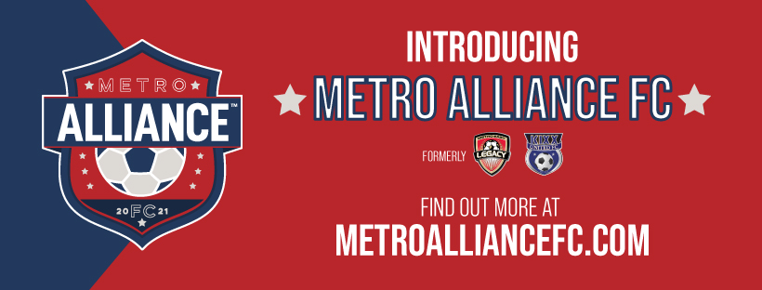

SUBJECT LINE: ATTENTION LEGACY FC AND KIXX UNITED FC: INTRODUCING METRO ALLIANCE FC!
EMAIL LANGUAGE:
Have you heard the news of the merging of Metro East Legacy FC and KiXX United FC into Metro Alliance FC? We are all excited to achieve ONE DREAM as ONE TEAM.
Please check out our new website at MetroAllianceFC.com and like our new Facebook Page!
If you have any questions or concerns in the meantime, please feel free to email or call me.
LET’S GO ALLIANCE!!!!!
Coach

