SOCIAL POST #1 – KIXX SPECIAL ANNOUNCEMENT:
FACEBOOK
IMAGE:
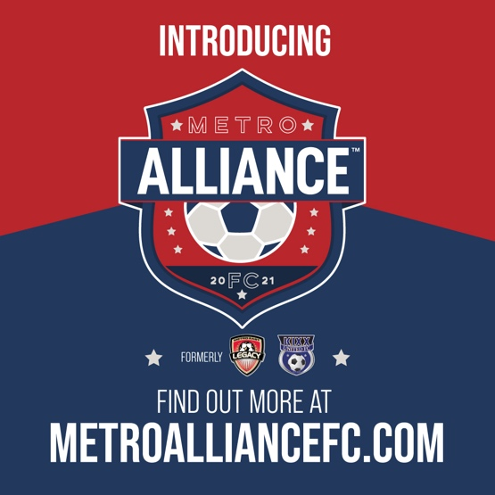
TEXT LANGUAGE:
ARE YOU READY FOR THE NEWE POWERHOUSE IN YOUTH SOCCER? KiXX United FC is joining forces with Metro East Legacy FC to create Metro Alliance FC. Learn more at www.metroalliancefc.com
TWITTER
ARE YOU READY FOR THE NEW POWERHOUSE IN YOUTH SOCCER? KiXX United FC is joining forces with Metro East Legacy FC to create Metro Alliance FC. Learn more at www.metroalliancefc.com

SOCIAL POST #2 – LEGACY SPECIAL ANNOUNCEMENT:
FACEBOOK
IMAGE:
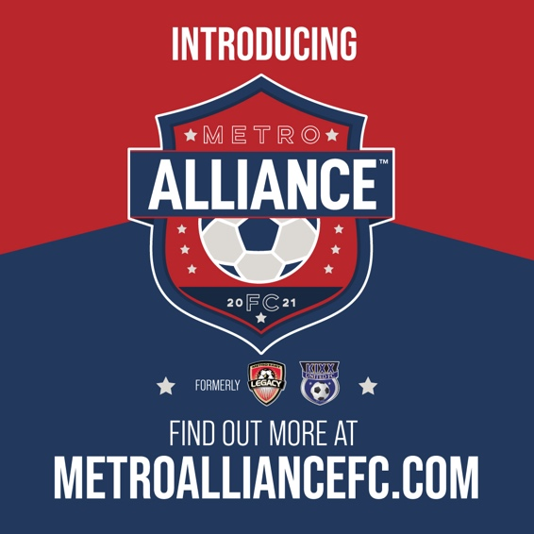
TEXT LANGUAGE:
ARE YOU READY FOR THE NEW POWERHOUSE IN YOUTH SOCCER? KiXX United FC is joining forces with Metro East Legacy FC to create Metro Alliance FC. Learn more at www.metroalliancefc.com

TWITTER
ARE YOU READY FOR THE NEW POWERHOUSE IN YOUTH SOCCER? KiXX United FC is joining forces with Metro East Legacy FC to create Metro Alliance FC. Learn more at www.metroalliancefc.com

SOCIAL POST #3 – GENERAL METRO ALLIANCE POST
FACEBOOK
IMAGE:
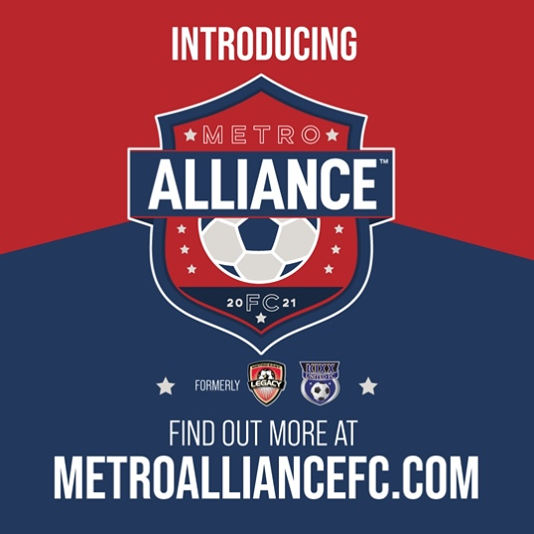
TEXT LANGUAGE:
ONE TEAM. ONE DREAM. 800 COMPETITORS. 1 ALLIANCE. Check out the new powerhouse in youth soccer www.metroalliancefc.com

TWITTER
ONE TEAM. ONE DREAM. 800 COMPETITORS. 1 ALLIANCE. Check out the new powerhouse in youth soccer www.metroalliancefc.com

